EXP.NO: 1 | Web Page Creation using HTML
DATE: 29/01/2025 | Web Page Creation using HTML

AIM:
To create a web page that embeds a map with hotspots, frames, and links. The web page should be designed using HTML, incorporating embedded, external, and inline CSS for styling. This exercise aims to enhance understanding of integrating multimedia elements like maps, creating interactive hotspots, and organizing content using frames while applying different CSS techniques for styling.

ALGORITHM:
1)Create the HTML Structure:
- Set up the basic HTML document using <!DOCTYPE html>, <html>, <head>, and <body> tags.
- In the <head> section, link the external CSS file using the <link> tag, define the title, and include necessary metadata.
- In the <body>, create the required elements:
Frames:
Use the <frameset> tag to create a frame layout. (Since <frameset> is obsolete in modern HTML, <iframe> is recommended.)
Map:
Use the <img> tag to display the map image.
Hotspots:
Create clickable regions on the image using the <map> and <area> tags.
Links:
Add hyperlinks using the <a> tag to navigate to different sections of the page or to external websites.
2) Create CSS Styles:
- External
Define styles such as colors, fonts, spacing, and layout in a separate CSS file to maintain a consistent design across the webpage.
- Inline
Apply styles directly within HTML elements using the style attribute (for example, inside <div> or <p> tags) when specific styling is required.
- Embedded
Use the <style> tag inside the <head> section to define styles for particular elements such as maps, frames, and text.
3) Map with Hotspots:
- Use the <map> tag to create an image map.
- Define clickable areas using the <area> tag and specify the coordinates with the coords="x,y,x2,y2" attribute to mark the hotspot regions on the image.
4) Frames:
- Use the <iframe> tag to embed external content such as maps or webpages.
- Important attributes include:
  - src – URL of the page to display
  - width – Width of the frame
  - height – Height of the frame
5) Add Links:
- Inside the <body>, use the <a> tag to create navigation links that direct users to other sections of the webpage or external sites.
6) Test the Page:
- Test the webpage to ensure that frames, hotspots, and links function correctly.
- Verify that the hotspots on the map are clickable and that the linked content loads properly.
- Confirm that all styles are applied correctly using inline, embedded, and external CSS.
CODE:
Index.html:
<!DOCTYPE html>
<html lang="en">
<head>
<meta charset="UTF-8">
<meta name="viewport" content="width=device-width, initial-scale=1.0">
<title>Hotel Booking</title>
<link rel="stylesheet" href="style.css">
</head>

<body>

<header class="navbar">
<div class="logo">StayEase</div>
<nav>
<a href="https://www.makemytrip.com/hotels/chennai_stays_guindy-details-chennai.html">Stays</a>
<a href="https://www.makemytrip.com/flight/search?tripType=O&itinerary=PNQ-DEL-11/02/2026&paxType=A-1_C-0_I-0&cabinClass=E&sTime=1770831199828&forwardFlowRequired=true&action=FLTSRCH&intl=false&cmp=SEM%7CD%7CDF%7CG%7CRoute%7CGrouped%7CRoute-ToptoMid_DT%7CDF_Route_Exact_Top%7CPune_Delhi_Exact%7CRSA&gad_source=1&gad_campaignid=11294711653&gbraid=0AAAAAD5Az1THsh8XnxpRZXw7Ij13c3OzV&gclid=Cj0KCQiA-YvMBhDtARIsAHZuUzKfrgDXLg1j8c8KnZ_kl-j-USGl483csoz1M0IJLW7sKWv2W0ys5OkaAi00EALw_wcB&isSemFlow=true">Flights</a>
<a href="https://www.justdial.com/Chennai/Car-Rental-For-Hotels/nct-11276216">Cars</a>
<a href="https://www.expedia.co.in/deals?locale=en_GB&siteid=27&semcid=IN.UB.GOOGLE.GT-c-EN.HOTEL&semdtl=a121749366368.b1173665751731.g1kwd-24566262.e1c.m1Cj0KCQiA-YvMBhDtARIsAHZuUzIBIiDr3qIbD1JYIyjR1lbwBK87IUZkt1t4z0hFSrEFTuGbhddfVRgaAlb7EALw_wcB.r1.c1.j19298685.k1.d1716261807172.h1e.i1.l1.n1.o1.p1.q1.s1hotel%20deals.t1.x1.f1.u1.v1.w1&gad_source=1&gad_campaignid=21749366368&gbraid=0AAAAACTxZ9bZ4RWAYgsrzDYHC87dPXzx7&gclid=Cj0KCQiA-YvMBhDtARIsAHZuUzIBIiDr3qIbD1JYIyjR1lbwBK87IUZkt1t4z0hFSrEFTuGbhddfVRgaAlb7EALw_wcB">Deals</a>
<a href="index2.html">Login</a>
</nav>
</header>

<section class="hero">
<center>
<h1>Find Your Perfect Stay</h1>
<p>Search deals on hotels, homes, and much more...</p>

<div class="search-box">
<form action="location.html">
<input type="text" placeholder="Enter city or hotel name">
<input type="date">
<button type="submit">Search</button>
</form>
</div>
</center>
</section>

<section class="hotels">
<h2>Top Hotel Picks</h2>

<div class="hotel-grid">

<div class="hotel-card">
<img src="ravi.png" alt="Hotel 1">
<h3>Ocean View Resort</h3>
<p>From ₹3,500 / night</p>
<a href="index2.html" class="bt">Book Now</a>
</div>

<div class="hotel-card">
<img src="karthi.png" alt="Hotel 2">
<h3>City Center Hotel</h3>
<p>From ₹2,800 / night</p>
<a href="index2.html" class="bt">Book Now</a>
</div>

<div class="hotel-card">
<img src="selva.png" alt="Hotel 3">
<h3>Luxury Palace</h3>
<p>From ₹5,500 / night</p>
<a href="index2.html" class="bt">Book Now</a>
</div>

</div>
</section>
<center>
<div class="map-box">
<iframe
src="https://www.google.com/maps?q=Chennai&output=embed"
loading="lazy">
</iframe>
</div>
</center>

<footer class="footer">
<p>© 2026 StayEase. All rights reserved.</p>
</footer>

</body>
</html>

Style.css:

* {
margin: 0;
padding: 0;
box-sizing: border-box;
font-family: Arial, sans-serif;
}

body {
background: #f5f5f5;
color: #333;
}

.navbar {
background: #003580;
padding: 15px 30px;
display: flex;
justify-content: space-between;
align-items: center;
}

.navbar .logo {
color: white;
font-size: 24px;
font-weight: bold;
}

.navbar a {
color: white;
margin-left: 20px;
text-decoration: none;
font-weight: 500;
}

.navbar a:hover {
text-decoration: underline;
}

.hero h1 {
font-size: 40px;
margin-bottom: 10px;
color:black;
}

.hero p {
font-size: 20px;
margin-bottom: 25px;
color:black;
}

.search-box {
display: inline-flex;
gap: 10px;
}

.search-box input {
padding: 12px;
border: none;
border-radius: 5px;
}

.search-box button {
padding: 12px 20px;
background: #0071c2;
border: none;
color: white;
cursor: pointer;
border-radius: 5px;
}

.bt {
padding: 5px 10px;
background: #0071c2;
border: none;
color: white;
cursor: pointer;
border-radius: 5px;
text-decoration: none;
}

.search-box button:hover {
background: #005ea6;
}

.hotels {
padding: 40px 30px;
}

.hotels h2 {
margin-bottom: 20px;
font-size: 28px;
}

.hotel-grid {
display: flex;
gap: 20px;
justify-content: center;
}

.hotel-card {
background: white;
width: 30%;
border-radius: 10px;
overflow: hidden;
box-shadow: 0px 2px 10px rgba(0,0,0,0.1);
text-align: center;
padding: 10px;
}

.hotel-card img {
width: 100%;
height: 200px;
object-fit: cover;
}

.hotel-card h3 {
padding: 15px 0;
font-size: 22px;
}

.hotel-card p {
color: #0071c2;
font-weight: bold;
margin-bottom: 12px;
}

.hotel-card button {
background: #0071c2;
padding: 10px 15px;
border: none;
color: white;
margin-bottom: 15px;
cursor: pointer;
border-radius: 5px;
}

.hotel-card button:hover {
background: #005ea6;
}

.footer {
background: #003580;
color: white;
text-align: center;
padding: 15px;
margin-top: 40px;
}

OUTPUT:
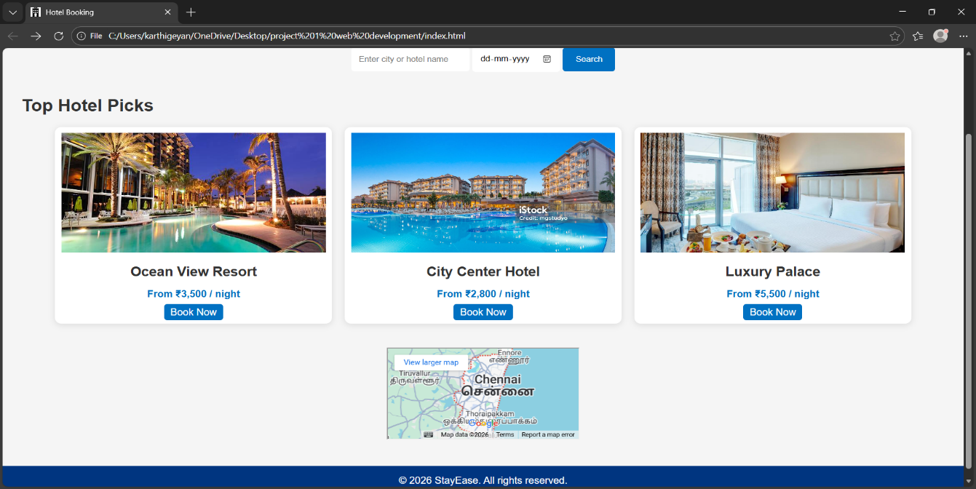

RESULT:
Html Page is created with embedded Chennai map along with hot spot, frames ,map &
links.

